**Title Page**

**Course:** Programming Fundamentals (CT-175)

**Problem Statement:**

**The problem:**

Running a superstore and managing its data, which includes inventory, customer information, and checkout records is necessary for shopkeepers. However, doing all of this manually can be a significant challenge for them. Firstly, managing this large amount of data manually is not user-friendly. Secondly, it can lead to errors while managing inventory, registering customers, and administering discounts. Moreover, this old register method is time-consuming and inefficient.

**The proposed solution:**

Keeping in mind, the problems faced by shopkeepers regarding data handling, we designed a Kirana Store Data Base Management System. This program includes an interface with admin access where the shopkeeper can handle store inventory, and manage customers and discounts. The financial management of the shop can be done through this program. Other than that, the program provides a digital ordering system for customers at the local level. The program aims to provide an efficient way to manage data for shopkeepers with no chance of error.

**Functionalities Map:**

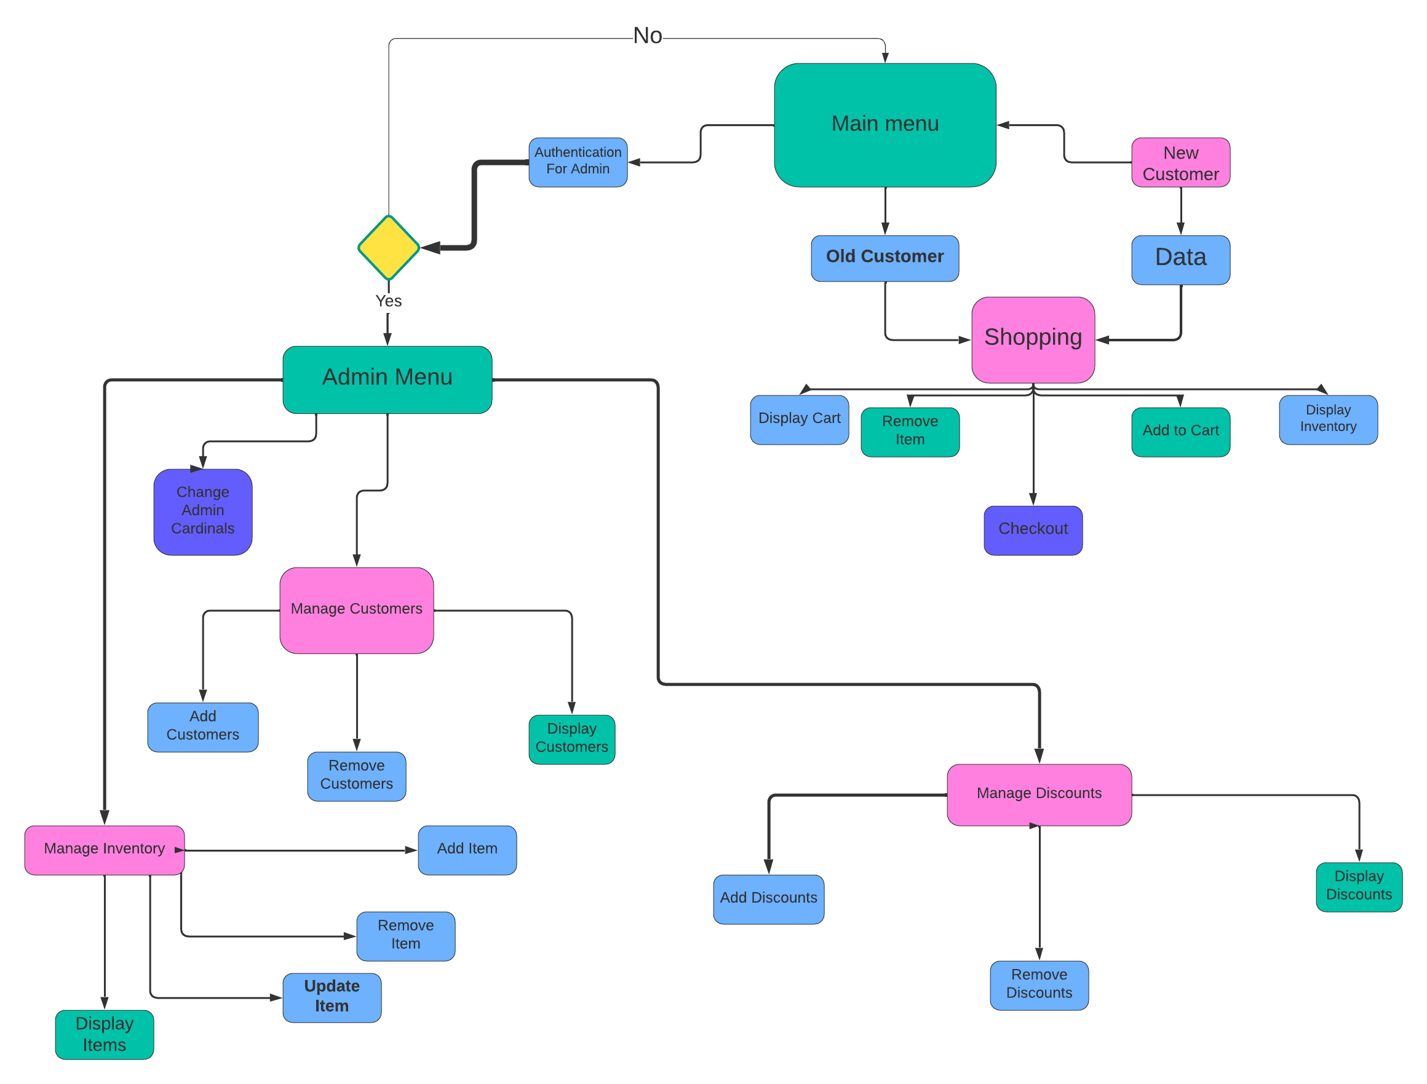

**Functionalities:**

Main Menu:

Admin Menu: 5

Ménage Inventory: 7

Manage Customers: 8

Manage Discounts: 8

Change Admin Cardinals: 9

New Customers: 9

Old Customer: 10

Shopping Function: 11

Display Inventory: 12

Display section wise inventory: 13

Add items to Cart: 13

Remove Items from Cart: 14

Display Cart: 15

Checkout: 16

Main Function:

Main function Firstly, load customers from Customer file, Inventory from inventory file and then give the user options, that whether he want to continue with admin account, new customer(I(f new than registered him/her first), old customer, etc.

Then redirect them to their respective functions.

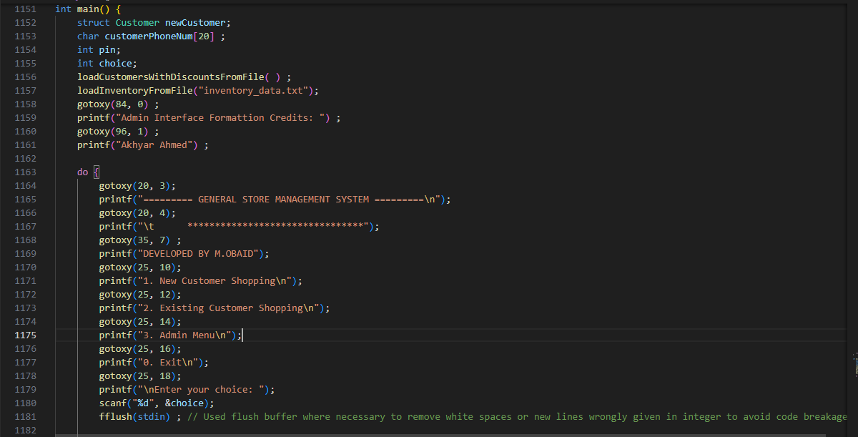

# Admin Menu:

Admin menu first authenticate whether, the user put right info(Username, admin) then, it gave options to user to manage inventory, manage customers, manage discounts, etc.

Then redirect them to their respective functions.

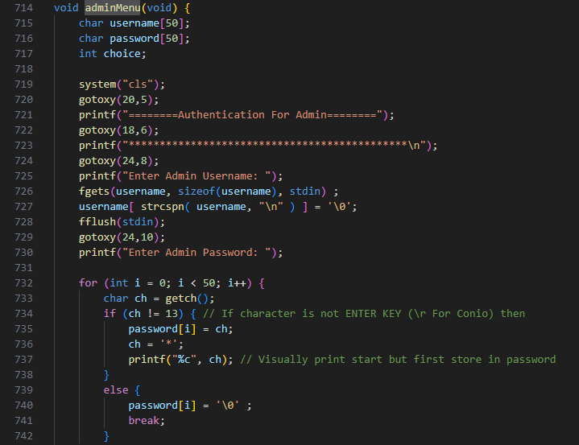

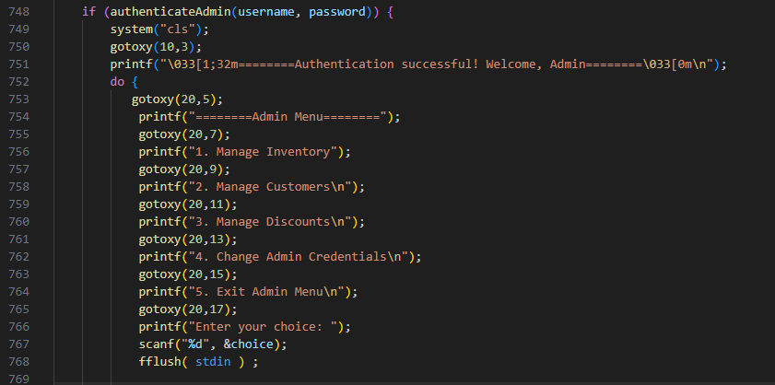

## Ménage Inventory:

In this section, Admin can manage inventory, he/she can add items, remove items, update items, also can see whole inventory, etc.

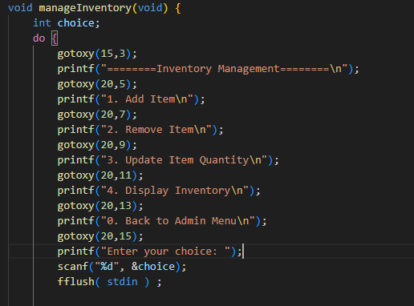

## Manage Customers:

In this section, Admin can manage Customers, he/she can add customers, remove customers, also can Display customers, etc.

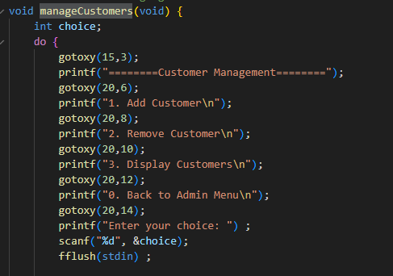

## Manage Discounts:

In this section, Admin can manage Discounts, he/she can add discounts, remove discounts, also can see whole discount list, etc.

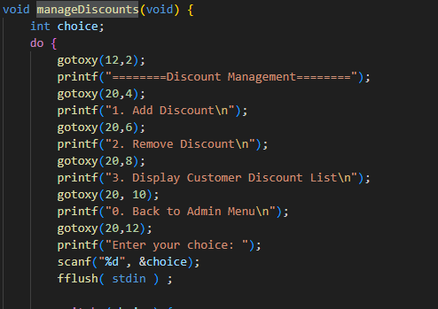

## Change Admin Cardinals:

It change the admin Details like, username, password, etc.

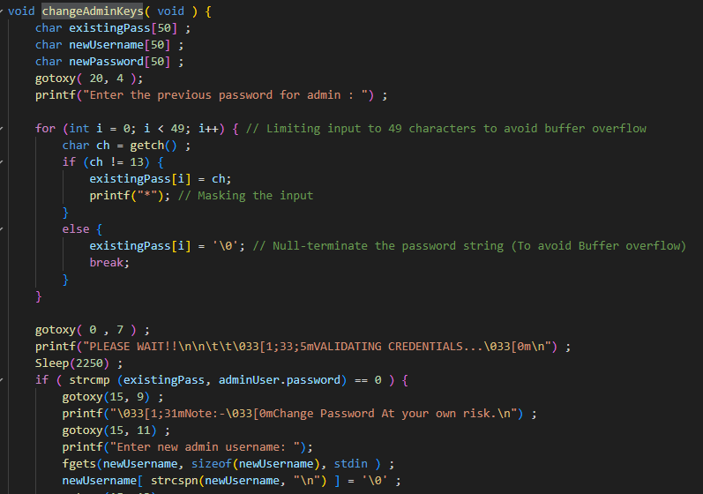

# New Customers:

In old Customer Section, It first collect the information from user than store his data in the customer list then redirect it to Shopping function.

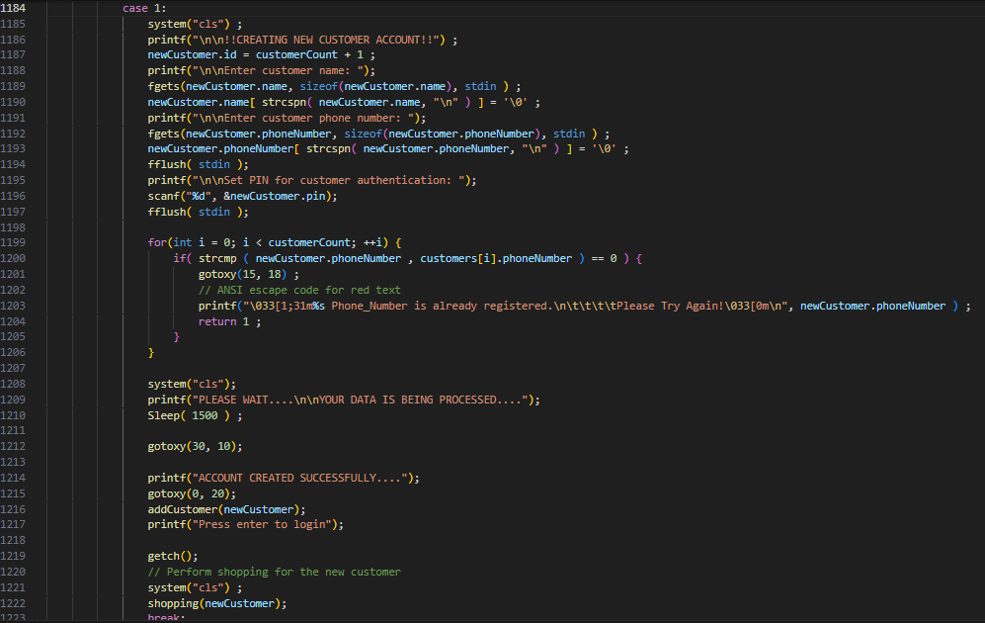

# Old Customer:

In old Customer Section, It first collect the information from user than authenticate the data whether user is an old customer or not, if user’s data found in the customer list then redirect it to Shopping function.

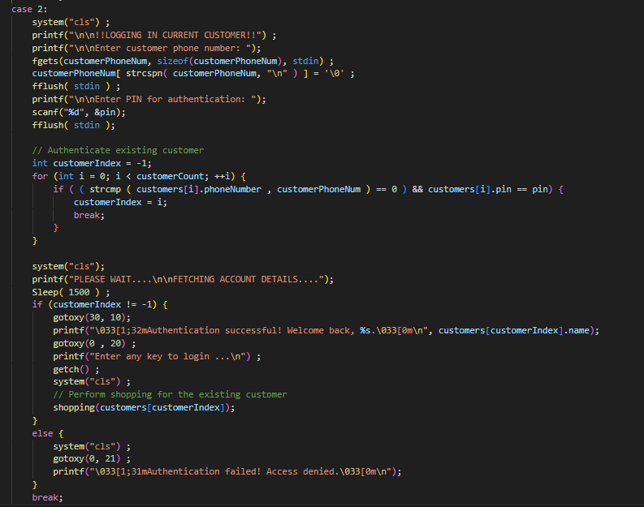

## Shopping Function:

The shopping function display the user options like, display whole inventory, display section wise inventory, Add items to Cart, Remove Items from Cart, Display Cart, Checkout and exit shopping.

When user select any option then it perform that task.

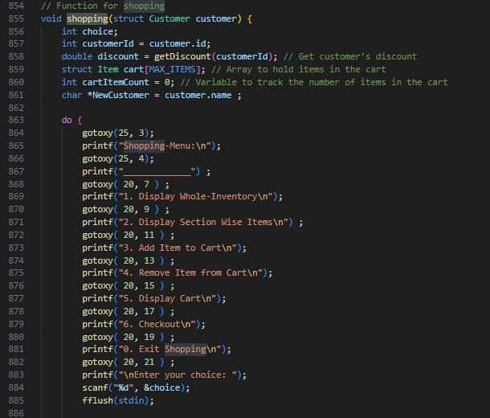

### Display Inventory:

It display all the items currently available in the inventory.

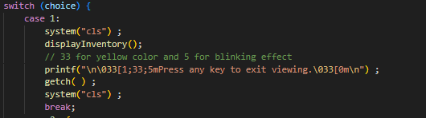

### Display section wise inventory:

It gives the user options of different sections in the inventory (like, Dairy, grains, beverages, snacks, etc.) If user select any category it shows the items available in that Category.

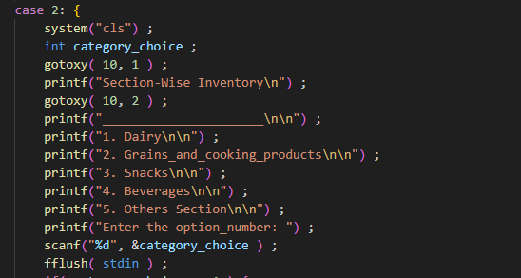

### Add items to Cart:

It ask user to enter the Id number of item and quantity and if, the Id number to any item in the product list, and user’s desired quantity available in the inventory than, it add that item in the Cart and display the details.

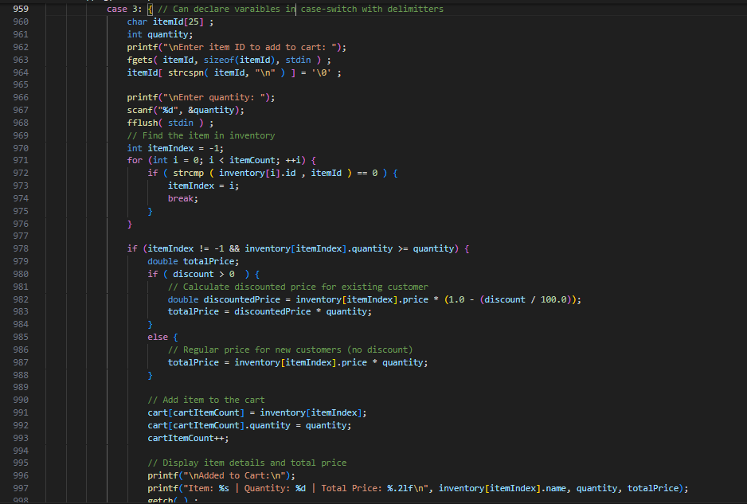

### Remove Items from Cart:

It ask user to enter the Id number of item and if, the Id number match to any item in the cart, it remove that item.

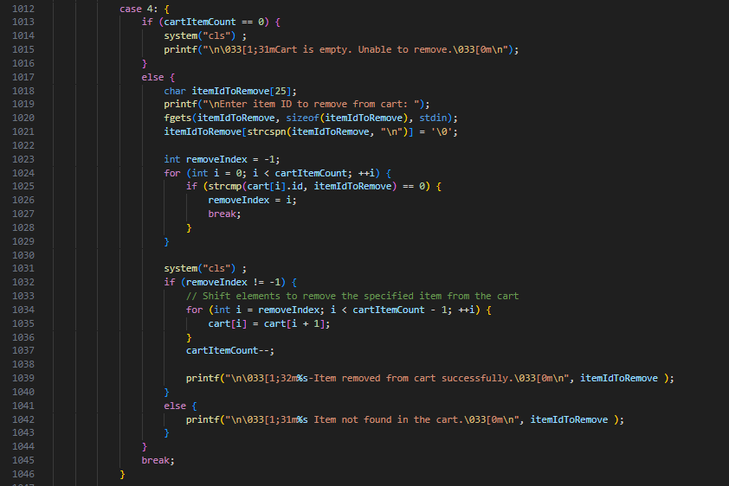

### Display Cart:

It Display the items in the Cart with all Details.

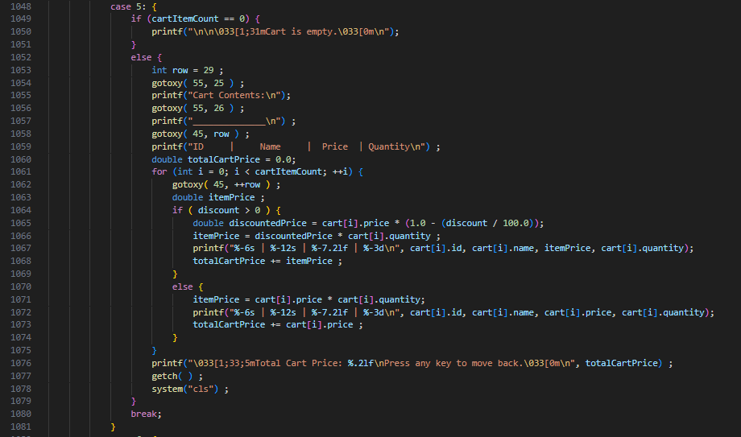

### Checkout:

It Display the items in the Cart with all Details and display the total payable amount then complete checkout process.

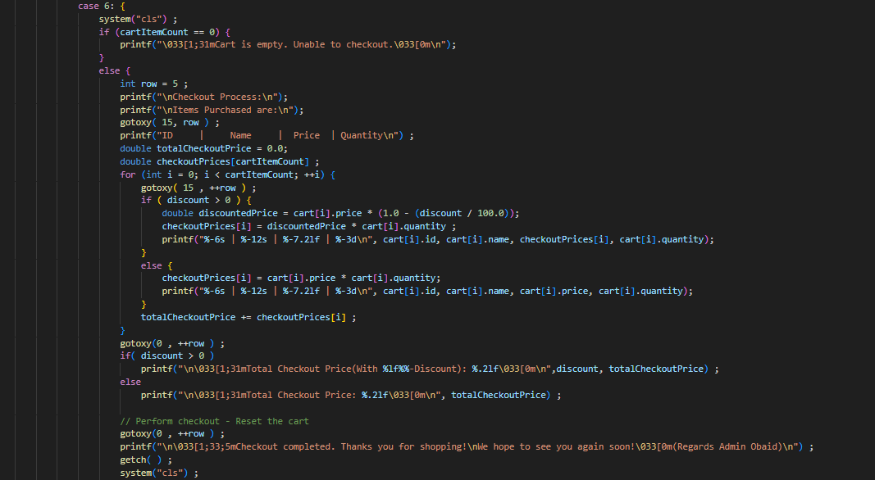

**Tools used:**

Visual Studio Code